**Name:** M. Miller

**Date:** 2023-02-12

**Course:** IT_FDN_130_A_Wi_23_Foundations_of_Databases_and_SQL_Programming

**GitHub Link**: <https://github.com/uw204773/A06_MMiller>

**Assignment 06 – Views**

# Introduction

In the assignment 05 document you asked us to:

1. Explain when you would use a SQL View.
2. Explain are the differences and similarities between a View, Function, and Stored Procedure.

# Topic

## SQL Views

Views are handy ways to allow the viewing of data. In an interesting way they almost act as hyperlinks would, to a specific file. You can edit the file, or actual table, as many times as you like, but visiting that information only ever see your latest version. They can read what is there, without affecting the true construction or elements of your actual table.

Also, views are handy in that you can build a user-friendly view when the actual data behind the view is too complicated and risks being misunderstood by an end user.

A view can be named anything, but requires the schema to be a part of the naming address, and where there is no schema you can simply use the prefix ‘dbo.

## Functions

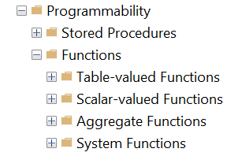

Though, views are limited in their capability. A Function allows arguments and parameters to be applied to one or more SQL statements. The function can be stored like a view can be and later referenced when called.

Functions are used to define, and thus have very rigid structure. They must use a return, to note what information and type that the function is supposed to return.

## Stored Procedures

A stored procedure can use reference views, or call upon functions as a part of its process. Though, stored procedures, when called, aren’t static, read-only, returns like views have to be. A stored procedure is much more powerful. It doesn’t have to return with information either, like a function. A stored procedure is a powerful script of instructions that have the power to create, insert, update, and delete.

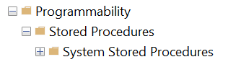

# Summary

Views enable you to create user-friendly windows, where others can access and read your table information, in a safe environment.

Functions are one or more statements that meet a set of given parameters and return to you what you’ve asked for. Though, this feature can only call, it cannot incite actions.

Stored procedures can incite action, through a set of written stored procedures that once enacted, proceed to create, insert, update, delete items called out.